**SCOPE OF THE PROJECT:**

The scope of the project is concentrating on how to manage the drug distribution and its inventory activities and applications of the drug in easy, efficient, and functional way. The following lists are in our scope:

* To allow the staff members, Manager & Executive Manager to login.
* To Sell the Drugs to the customers with the reference to authorized Prescription.
* Give access to the Pharmacist, Manager & Executive to Manage the Inventory.
* Send the Required Quantity Information to the Supplier.
* Manager & Executive Manager will have the permissions to Manage Pharmacists.
* Generate Daily, Weekly, Monthly Sales Report with requests made Manager or Executive Manager.
* Manager will be having Access to Verify sales for the Particular Store.
* Executive Manager can able to Verify Sales for the each and every store.
* Manager can able to manage particular store details & Executive Manager can able to manage all the stores.

**STATEMENT OF PROBLEM:**

This project is developed mainly to manage, distribute & sell drugs in an appropriate way. The purpose of the project entitled to computerize the Management of drug store to develop software which is friendly, simple, fast, and cost – effective. It deals with the collection of drugs information, distribution details, etc.

The main function of the system is to manage the drugs by the pharmacist and retrieve these data as and when required, and also to manipulate these details meaningfully. The importance:

1. Efficiently maintains the details about the drug

2. Simultaneously updates changes made to any data, item in the entire data base.

3. This function of this particular System deals with registering the new drug and giving unique Identification Number to the drug. This number is unique throughout the System for identifying the drug.

4.System deals with all operations required to be done the pharmacist like search the medicine,sell it and generate the order, delete or modify the order & Also responsible for the managing the Inventory.

5.Manager will be required operate at the store level & Executive Manager at the High level.

**OBJECTIVE OF THE PROJECT :**

The ultimate aim of the study is to automate the routine function of pharmacy management system and overcome the problems associated with the manually function organization. The aim and objectives are to handle the following;

1. To change the existing manuals system by introducing a computerized system.overcome the problems associated with the manually function organization.

2. To reduce human dependability and lapses.

3. To design a system for easy information storage update and retrieval.

4. To bring into focus the important of computer in drug management .

5. To improve the operational speed for faster calculation of sentences.

6. To provide facility for good access to date store in the database.

**REQUIREMENT IN DEVELOPING THE SYSTEM:**

Software requirements For successful completion of our system we will use the following software requirement. These are:-

* Spring Tool Suite.4
* Tomcat Server (STS)
* MySQL
* HTML,CSS/SCSS,JavaScript,AJAX,BootStrap,JQuery
* Hibernate
* Version Control System: Git
* Scrum Board: Trello
* PostMan (Server Side Testing)

**MATERIAL REQUIREMENTS :**

Computer/laptop with more than 320GB hard disk, more than 4GB RAM .

**FUNCTIONAL REQUIREMENTS FOR DRUG STORE MANAGEMENT :**

Functional requirements are the intended behaviors of the system. This behavior may express as services, tasks or functions that the system is required to perform. Functional requirements define what the system is supposed to do. Our application will be developed to manage and process the data by using the required data base.

The database of the system provides the following functionality:

1. The software must allow input of products data from Administrator and secured access , and from the data streaming real-time monitoring equipment.

2. The project must request username and password for access to data,only after authentication will allow access to the system.

3. The project must require high levels of error correction and input validation.

4. The project must allow browsing by the Administrator and Staff to access and update information products and customers ,vendors.

5. The project must identify the products and customer by a unique numeric identifier derived from a function performed on the Customer’s birth date or product id.

6. The software to be developed must operate without interruption twenty-four hours a day.

7. The software must retrieve,update and store data from multiple input.

**8. The software must allow full and complete record search queries by users.**

**Data Entry:**

**The data entry is the functionality that is used to enter the data of the drug in to the system.The system serves different interface that can manage data entry mechanisms in the drug management system in drug store.**

**The main data entries are the following:**

* **Recording the description of drug.**
* **Update data**
* **Login**
* **Search the needed medicine data**

**Dataprocessing:**

The system on input data will provide the following data:

* Saving the product data
* Update data
* Clear the data
* Generating report
* Search requested drug’s data
* Exit

**Report Generation:**

* **Total number of product that are sealed and unsealed in the stock.**
* **Total number of drugs that are sold from drug store.**
* **Products with required registration date,name, quality, quantity,model, cost,expiry date...etc.**
* **Total number of drugs that are stored by their pharmacological order.**

**NON FUNCTIONAL REQUIREMENTS FOR DRUG STORE MANAGEMENT :**

**Non functional requirements is a requirement that specifies criteria that can be used to judge the operation of a system, rather than specific behaviors.Non functional requirements define how a system is supposed to be.**

**Qualities that is nonfunctional requirements can be divided into two main categories.**

* **Execution qualities such as security and usability which are observable at runtime.**
* **Evolution qualities such as testability,maintainability,extensibility and scalibity, which are embodied in the static structure of the software system.**

**1. Response Time should be minimum.**

**2. The software interface must follow design conventions**

***SYSTEM DESIGN***

***System design is the process of defining the architecture, components, modules, interfaces and data for a system to satisfy specified requirements through system modelling. It can also be seen as the application of systems theory to produce development. The design of this system will be user friendly. It shall be designed in such a way that employees will be able to navigate easily through the information supplied on the system.***

***AGILE APPROACH***

***The agile approach is a software development approach based on values, principles, and core practices. The four values are communication, simplicity, feedback, and courage.***

***When these four control variables are properly included in the planning, there is a state of balance between the resources and the activities needed to complete the project.***

***EXPLORATION***

***During exploration, you will explore your environment, asserting your conviction that the problem can and should be approached with agile development, assemble the team, and assess team member skills.***

***PLANNING***

***The next stage of the agile development process is called planning. In contrast to the first stage, planning may only take a few days to accomplish. In this stage you and your customers agree on a date anywhere from two months to half a year from the current date to deliver solutions to their most pressing business problems***

***ITERATIONS TO THE FIRST RELEASE***

***The third stage in the agile development process is composed of iterations to the first release. Typically these are iterations of about three weeks in duration. You will be pushing yourself to sketch out the entire architecture of the system, even though it is just in outline or skeletal form. One goal is to run customer-written functional tests at the end of each iteration.***

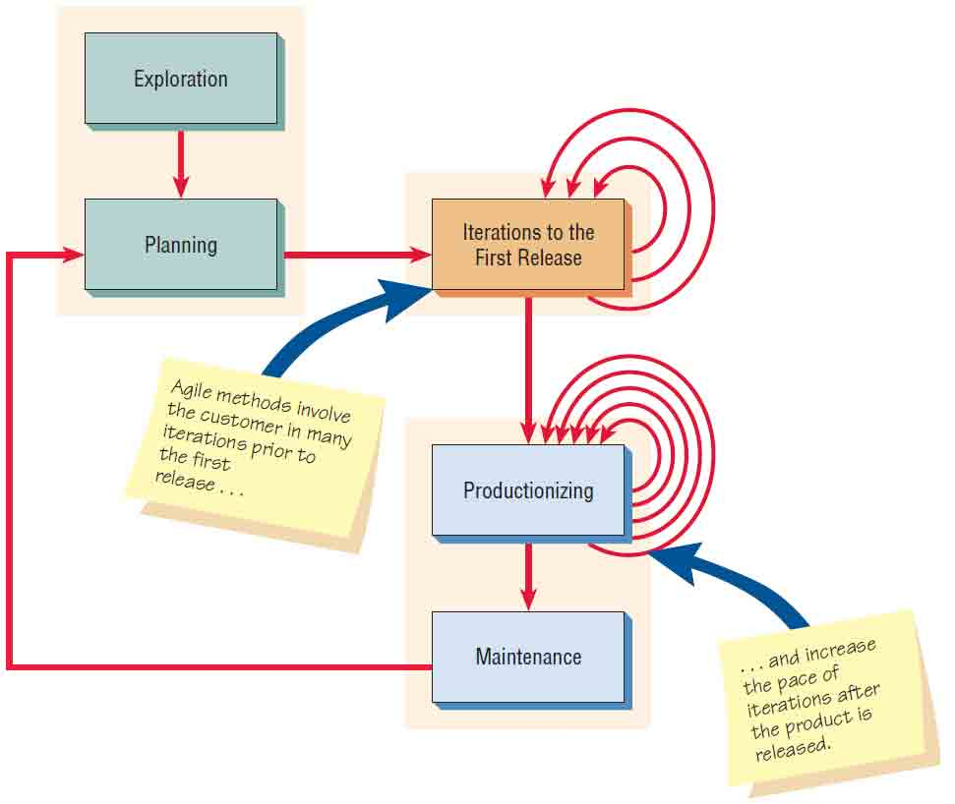

***PRODUCTIONIZING***

***Several activities occur during this phase. In this phase the feedback cycle speeds up so that rather than receiving feedback for an iteration every three weeks, software revisions are being turned around in one week. You may institute daily briefings so everyone knows what everyone else is doing. The product is released in this phase, but may be improved by adding other features.***

***MAINTENANCE***

***Once the system has been released, it needs to be kept running smoothly. New features may be added, riskier customer suggestions may be considered, and team members may be rotated on or off the team. The attitude you take at this point in the developmental process is more conservative than at any other time.***

**DATABASE SPECIFICATIONS:**

The database system to implement the back- end iof the system is MYSQL. Access to the system is made possible by a gui (Mysql workbench). The database name is pharmacy , structure and tables are described as follows :

* Users
* Products
* Invoice
* Locations
* Sales
* Storeproducts
* Supplierorder
* Supplierorderproducts

**Users**

|  |  |  |  |  |  |
| --- | --- | --- | --- | --- | --- |
| ***Field*** | ***Type*** | ***Null*** | ***Key*** | ***Default*** | ***Length*** |
| ***Id*** | ***Int*** | ***No*** | ***Primary Key*** |  | ***10*** |
| ***Name*** | ***Varchar*** | ***No*** |  |  | ***45*** |
| ***LocationId*** | ***int*** | ***NO*** | ***foreign key*** |  | ***45*** |
| ***Password*** | ***Varchar*** | ***No*** |  |  | ***45*** |
| ***Qualification*** | ***Varchar*** | ***Yes*** |  |  | ***45*** |
| ***Access*** | ***Int*** | ***Yes*** |  |  | ***10*** |
| ***Designation*** | ***Varchar*** | ***Yes*** |  |  | ***45*** |

**Products Table:**

|  |  |  |  |  |  |
| --- | --- | --- | --- | --- | --- |
| ***Field*** | ***Type*** | ***Null*** | ***Key*** | ***Default*** | ***Length*** |
| ***Name*** | ***Varchar*** | ***No*** | ***Primary key*** |  | ***45*** |
| ***Price*** | ***Bigint*** | ***Yes*** |  |  | ***10*** |
| ***Required*** | ***Varchar*** | ***yes*** |  |  | ***45*** |
| ***storeId*** | ***Int*** | ***No*** | ***Forgien key*** |  | ***10*** |
| ***available*** | ***Int*** | ***Yes*** |  |  | ***10*** |
| ***Chemical formula*** | ***Varchar*** | ***Yes*** |  |  | ***45*** |
| ***Description*** | ***Varchar*** | ***Yes*** |  |  | ***100*** |
| ***Manufacturer*** | ***Varchar*** | ***Yes*** |  |  | ***45*** |

**Invoice Table:**

|  |  |  |  |  |  |
| --- | --- | --- | --- | --- | --- |
| ***Field*** | ***Type*** | ***Null*** | ***Key*** | ***Default*** | ***Length*** |
| ***Id*** | ***Int*** | ***No*** | ***Primary key*** |  | ***11*** |
| ***Sales*** | ***Varchar*** | ***No*** |  |  | ***45*** |
| ***Totalprice*** | ***Bigint*** |  |  |  | ***10*** |
| ***Userid*** | ***Int*** | ***No*** | ***Foreign key*** |  | ***10*** |
| ***Customer name*** | ***Varchar*** | ***No*** |  |  | ***45*** |
| ***Customer phone*** | ***Varchar*** | ***No*** |  |  | ***45*** |
| ***dataofsale*** | ***Varchar*** | ***No*** |  |  | ***45*** |

**Locations Table:**

|  |  |  |  |  |  |
| --- | --- | --- | --- | --- | --- |
| ***Field*** | ***Type*** | ***Null*** | ***Key*** | ***Default*** | ***Length*** |
| ***Id*** | ***Int*** | ***No*** | ***Primary key*** |  | ***10*** |
| ***Address*** | ***Varchar*** |  |  |  | ***45*** |
| ***Brand name*** | ***Varchar*** |  |  |  | ***45*** |

**Sales Table:**

|  |  |  |  |  |  |
| --- | --- | --- | --- | --- | --- |
| ***Field*** | ***Type*** | ***Null*** | ***Key*** | ***Default*** | ***Length*** |
| ***Id*** | ***Int*** | ***No*** | ***Primary key*** |  | ***10*** |
| ***Invoice id*** | ***Int*** | ***No*** | ***Forgien Key*** |  | ***10*** |
| ***Price*** | ***Bigint*** | ***Yes*** |  |  | ***10*** |
| ***Quantity*** | ***Int*** | ***No*** |  |  | ***10*** |
| ***Tablet name*** | ***Varchar*** | ***No*** |  |  | ***45*** |

**Storeproducts Table:**

|  |  |  |  |  |  |
| --- | --- | --- | --- | --- | --- |
| ***Field*** | ***Type*** | ***Null*** | ***Key*** | ***Default*** | ***Length*** |
| ***Id*** | ***Int*** | ***No*** | ***Primary key*** |  | ***10*** |
| ***Location*** | ***Int*** | ***No*** | ***Forgien key*** |  | ***10*** |
| ***Product*** | ***Varchar*** | ***No*** | ***Forgien key*** |  | ***45*** |
| ***Required quantity*** | ***Int*** | ***No*** |  |  | ***10*** |
| ***Available quantity*** | ***Int*** | ***No*** |  |  | ***10*** |

Supplierorder Table:

|  |  |  |  |  |  |
| --- | --- | --- | --- | --- | --- |
| ***Field*** | ***Type*** | ***Null*** | ***Key*** | ***Default*** | ***Length*** |
| ***Id*** | ***Int*** | ***No*** | ***Primary key*** |  | ***10*** |
| ***Isfullfiled*** | ***Tinyint*** | ***No*** |  |  | ***2*** |
| ***Orderplaceddate*** | ***Varchar*** | ***No*** |  |  | ***45*** |
| ***OrderRequireddate*** | ***Varchar*** | ***No*** |  |  | ***45*** |
|  |  |  |  |  |  |
| ***Storeid*** | ***Id*** | ***No*** | ***Forgien ket*** |  | ***10*** |

**Supplierorderproducts Table:**

|  |  |  |  |  |  |
| --- | --- | --- | --- | --- | --- |
| ***Field*** | ***Type*** | ***Null*** | ***Key*** | ***Default*** | ***Length*** |
| ***Id*** | ***Int*** | ***No*** | ***Primary key*** |  | ***10*** |
| ***Product*** | ***Varchar*** |  | ***forgienkey*** |  | ***45*** |
| ***Quantity*** | ***Int*** |  |  |  | ***10*** |
| ***Supplierorderid*** | ***Int*** | ***No*** | ***Forgien key*** |  | ***10*** |

**ARCHITECTURAL SYSTEM DIAGRAM**

A flowchart is a type of diagram that represents a workflow or process. A flow chart can also be defines as a diagrammatic representation of an algorithm, a step-by-step approach of solving a task.

A flow chart shows the steps as boxes of various kinds, and their order by connecting the boxes with arrows. This diagrammatic representation illustrates a solution model to a given problem. Flow charts used in analyzing, designing, documenting or managing a process or a program in various fields.

The most common types of boxes in a flowchart are:

a) A processing step , usually called activity, and denoted as a rectangular box.

b) A decision, usually denoted as a diamond.

The proposed system takes the login input and matches with that of the database and depending on the user’s login their userType is being analyzed by the Database whether he/she is (Pharmacist, Executive Manager & Store Manager) is displayed along with their activities.

Firstly, the store manager is able to add and remove the pharmacist within the store and check on the sales report which maybe daily, weekly , monthly or yearly.

Second, the pharmacist is able to search a required product for the customer by name. Then he adds the product to the cart for selling and then checkout. He can even track the inventory of the products by updating about each product whenever it is sold.

Finally, the executive is able to manage any store and can perform the activities that are performed by both pharmacist and the store manager.

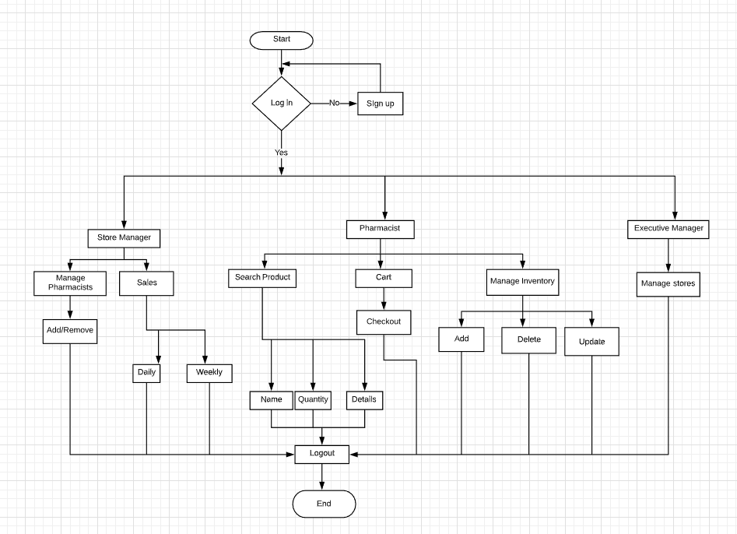

**USE CASE DIAGRAM :**

Use cases describe the behavior of the system when one of these actors sends one particular stimulus. This behavior is described textually. It describes the nature of the stimulus that triggers the use case; the inputs from and outputs to other actors, and the behaviors that convert the inputs to the outputs. The text of the use case also usually describes everything that can go wrong during the course of the specified behavior, and what remedial action the system will take. Use case diagrams are used for documenting the system’s behavior from the user’s point of view. Those diagrams are used to identify the processes/ functions and the main elements which form the system. The processes/functions are called use cases and the main elements are called actors. The diagram also shows the interactions that occur with each of the actors, with each use case. According to Files, “Use cases are an extremely important aspect of UML modeling. They allow developers to understand software systems from the user's perspective, and cause the whole system architecture to be driven by what the user wishes to do with the system”. Use case diagram (B. Meyer 1997) illustrates a set of use cases for a system, the actors of these use cases, the relations between the actors and these use cases, and the relations among the use cases. The UML notation for a use has the following three elements.

* **An oval represents a use case,**
* **A stick figure represents an actor,**

**An arrow between an actor and a use case represents that the actor initiates and/or participates in the process.**

**Informally speaking, a use case is a story or a case of using a system by some users to carry out a process. A bit more precisely speaking, a use case describes the sequence of events of some types of users, called Actors, using some part of the system functionality to complete a process.**

**An Actor represents a coherent set of roles that are entities external to the system can play in using the system, rather than representing a particular individual. An actor represents a type of users of the system or external systems that the system interacts with. In our project we have three actors each has its own activities /use cases.**

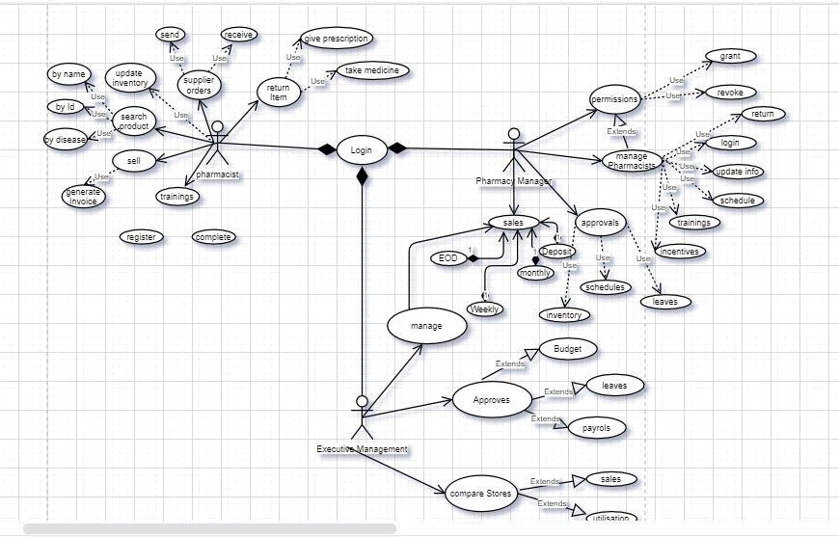

**USECASE DIAGRAM DESCRIPTION:**

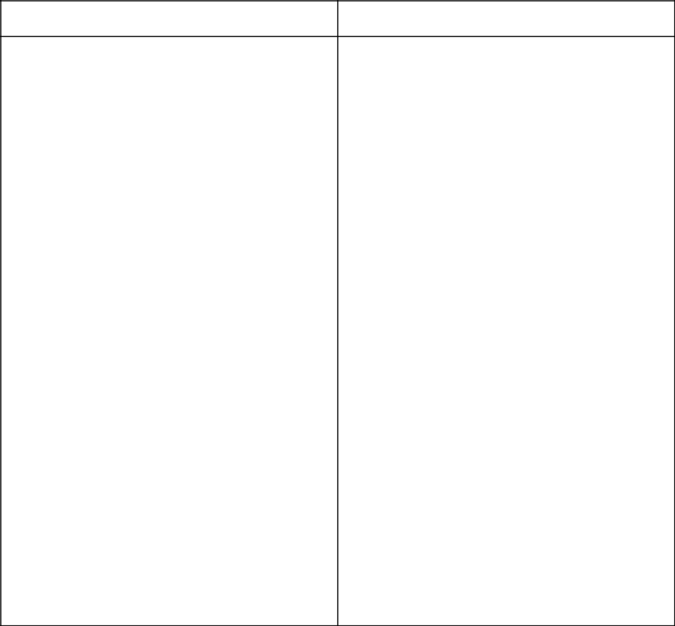

|  |  |
| --- | --- |
| **User Case Name** | **Login** |

|  |  |
| --- | --- |
| **ACTOR** | **Pharmacist,pharmacy** |
|  | **manager,Executive manager** |
|  |  |
| **Pre-condition** | **the actor should have user name and** |
|  | **password** |
|  |  |
| **Main flow** | **1. The actor open the system and click** |
|  | **login** |
|  | **2.the system display login screen** |
|  | **3.the user enter username and password** |
|  | **to login** |
|  | **4.the system check validity username and** |
|  | **password** |
|  | **5. the system login the user in** |
|  |  |
| **Post condition** | **User to access the required page** |
|  |  |
| **Alternative flow of event** | **4.1. the user didn’t type of the correct** |
|  | **displays username/password Or Do not** |
|  | **have an account.** |
|  | **4.2. The system display the corresponding** |
|  | **error try again message.** |

**USE CASE DESCRIPTION FOR GIVING USERNAME AND PASSWORD FOR THE USERS:**

|  |  |
| --- | --- |
| **Use Case Name** | **Creating users for username and** |
|  | **password information.** |
|  |  |
| **Actor** | **Executive Manager** |
|  |  |
| **Description** | **The Executive Manager create an account** |
|  | **for pharmacist, and Manager.And also** |
|  | **updates and deletes account.** |
|  |  |
| **Main Flow** | **1. The admin open the system and click** |
|  | **login.** |
|  | **2. The system display login form.** |
|  | **3. Admin enters username and password.** |
|  | **4. The system checks validity username** |
|  | **and password.** |
|  | **5. Admin enters the main page then click** |
|  | **on the displayed main page.** |
|  | **6. The system displays the registration** |
|  | **form for the pharmacist and cashier.** |
|  | **7. The administrator fills the form based** |
|  | **on the given data.** |
|  | **8. The system checks valid value for each** |
|  | **entry.** |
|  | **9. The system display users registered** |
|  | **successfully message** |
|  |  |
| **Post Condition** | **Users given username and password, is** |
|  | **performed successfully.** |
|  |  |
| **Alternate Event Flow** | **4.1 The admin didn’t type of the correct** |
|  | **username and password or don’t have** |
|  | **account.** |
|  | **4.2 The system display error message.** |
|  | **8.1 The admin didn’t fill the correct value** |
|  | **or missing some forms.** |
|  | **8.2 System display error message in order** |
|  | **to fill it again or to fill it order valid value.** |
|  |  |

**USE CASE DESCRIPTION FOR VIEWING DRUG RECORD:**

|  |  |  |
| --- | --- | --- |
| **UseCase Name** | **view drug record** | |
|  |  | |
| **Actor** | **Pharmacist, Manager** | |
|  |  | |
| **Description** | **to secure the information from an** | |
|  | **unauthorized access; to get full access in** | |
|  | **the activity** | |
|  |  | |
| **Pre-Condition** | **Allows the Pharmacist to view new** | |
|  | **changes based on the daily record.** | |
|  |  |  |
| **Main Flow** | **1.** | **Manager and pharmacist open the** |
|  | **system and click login.** | |
|  | **2.** | **The system displays the login form.** |
|  | **3.** | **The owner and pharmacist enter** |
|  | **username and password.** | |
|  | **4.** | **The system checks the validity of the** |
|  | **manager and pharmacist username and** | |
|  | **password.** | |
|  | **5.** | **Manager and pharmacist enter the main** |
|  | **page and click on view drug record form.** | |
|  | **6.** | **The system display form.** |
|  | **7.** | **Manager and pharmacist display the** |
|  | **drug record form.** | |
|  | **8.** | **Then display drug record for the** |
|  | **manager and pharmacist.** | |
|  |  | |
| **Post Condition** | **Manager and Pharmacist notify it is** | |
|  | **displayed successfully** | |
|  |  | |
| **Alternative case** | **1.The manager and pharmacist didn’t type** | |
|  | **the correct username and password, or do** | |
|  | **not have an account** | |
|  | **2. The system display corresponding** | |
|  | **error and try again message.** | |
|  |  |  |

**PHARMACIST ORDERING FOR REFILL:**

|  |  |
| --- | --- |
| **UseCase Name** | **Ordering for refill** |
|  |  |
| **Actor** | **Pharmacist** |
|  |  |
| **Description** | **ordering for refill** |
|  |  |
| **Pre-Condition** | **the actor should login into the system** |
|  |  |
| **Main Flow** | **1.The Pharmacist open the system and** |
|  | **click login.** |
|  | **2. The system displays the login form.** |
|  | **3.The Pharmacist enters username and** |
|  | **password.** |
|  | **4. The system checks validity username** |
|  | **and password.** |
|  | **5. Actor clicks on refill and search for the** |
|  | **product that has to be refilled and select** |
|  | **6.After selecting the product click submit** |
|  |  |
| **Post condition** | **Pharmacist orders for refill successfully.** |
|  |  |
| **alternative case** | **The admin didn’t type the correct** |
|  | **username and password, or do not have** |
|  | **an account** |
|  | **The system display corresponding error** |
|  | **and try again message.** |
|  |  |

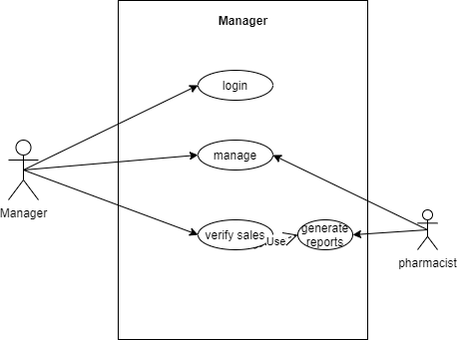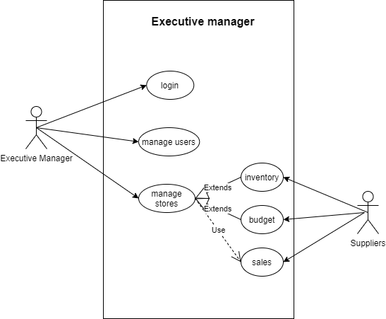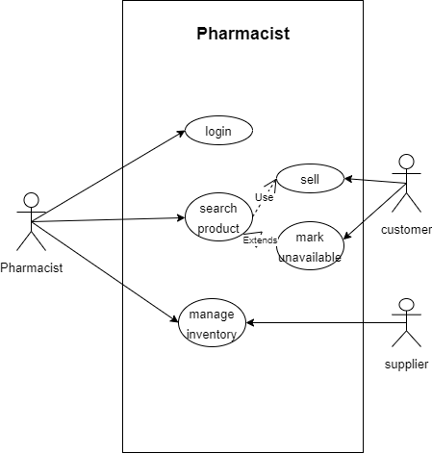

**CLASS DIAGRAM-(PENDING)**

**SEQUENCE DIAGRAMS:**

Sequence diagrams are used to model the logic of usage scenarios or the description of the potential way the system used. Sequence diagrams are a great way to validate and flesh out the logic of use case scenarios and to document the design of the system.

This is Sequence diagram of Pharmacy Management System which shows the interaction between the objects of Inventory, Sells, Medicines, Pharmacy.

Firstly in Login system, where pharmacist will be able to login in their account using their credentials. After login user can manage all the operations on Medicines, Inventory, Sells and Pharmacy. The various objects in the Pharmacy, Medicine, Inventory, Sells – interact over the course of the sequence and user will not be able to access this page without verifying the identity.

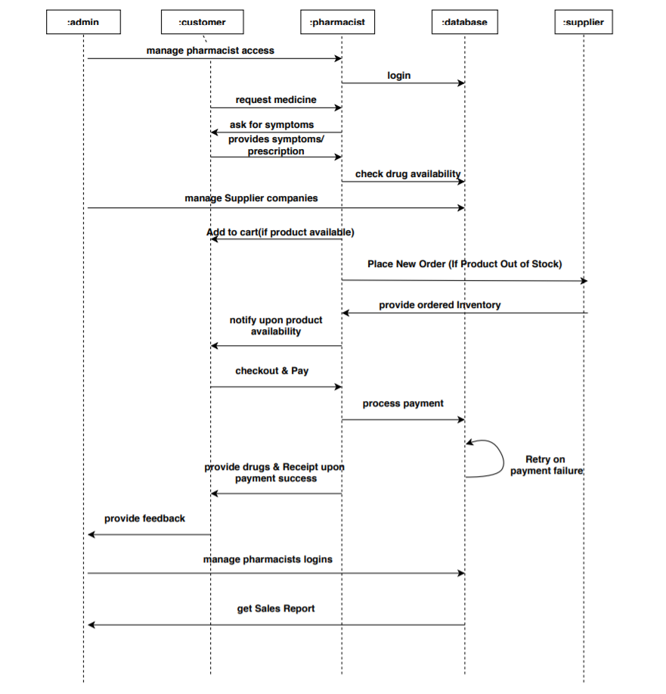

Then, looking according to the diagram, the customer will request for the medicine to pharmacist as per their requirements. So that the pharmacist will take a look over the stock in the database system and will reply soon to the same client. However, on the same time the admin will manage the stock to the suppliers. By that time, if the companies stock is getting finishing, supplier will place a new order to their stock.

**The process of payment and checkout is flexible. Customer, after receiving the stock according to their requirements, will pay to pharmacist and further pharmacist will put a record in the database. If the record is incorrect or any error occurs in the database, there is a retry on payment option. At last, customers feedback will sent to admin, so that admin gets an idea about their clients needs.**

**SYSTEM IMPLEMENTATION STRUCTURES :**

**WEB :**

System Implementation Structures are the lowest-level system elements in the system hierarchy (system breakdown structure).The implementation Structure starts with how the pages are displayed as soon as the application starts running.

The application begins with the Home Page, Which asks the authorized user(Pharmacist/Manager/Executive Manager) to login.

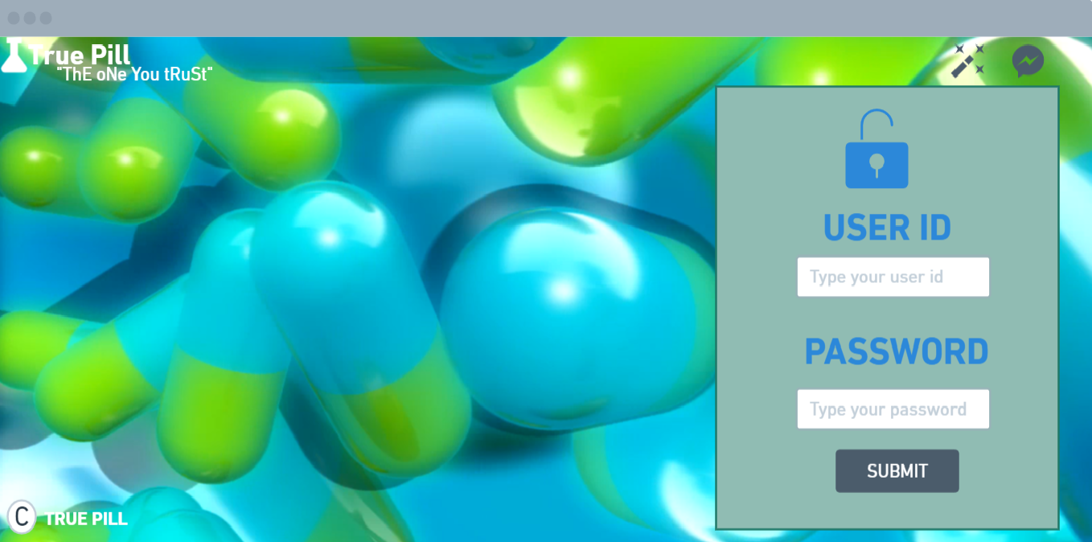

If the user logged in is a Pharmacist, then the homepage of the Pharmacist is displayed.

**string sql= select * from pharmacist where username==?&& password==?**

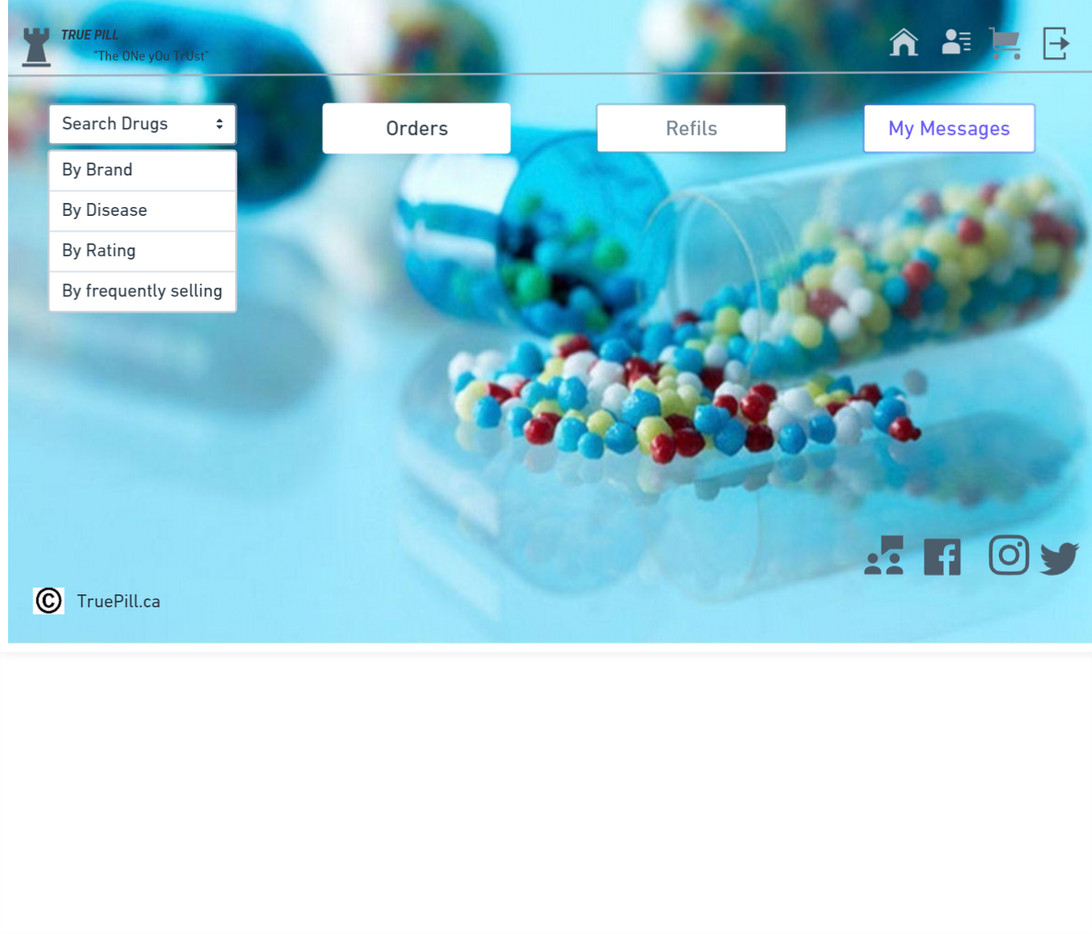

* The Pharmacist would be able to Search Products, Sale, Manage the Orders(Cart) and Manage Inventory(In Refills)
* The orders placed by a particular pharmacist would be listed out in the Cart tab, where we could Add/ delete a product before we checkout and finally Proceed to checkout and pay, get a copy of the receipt.

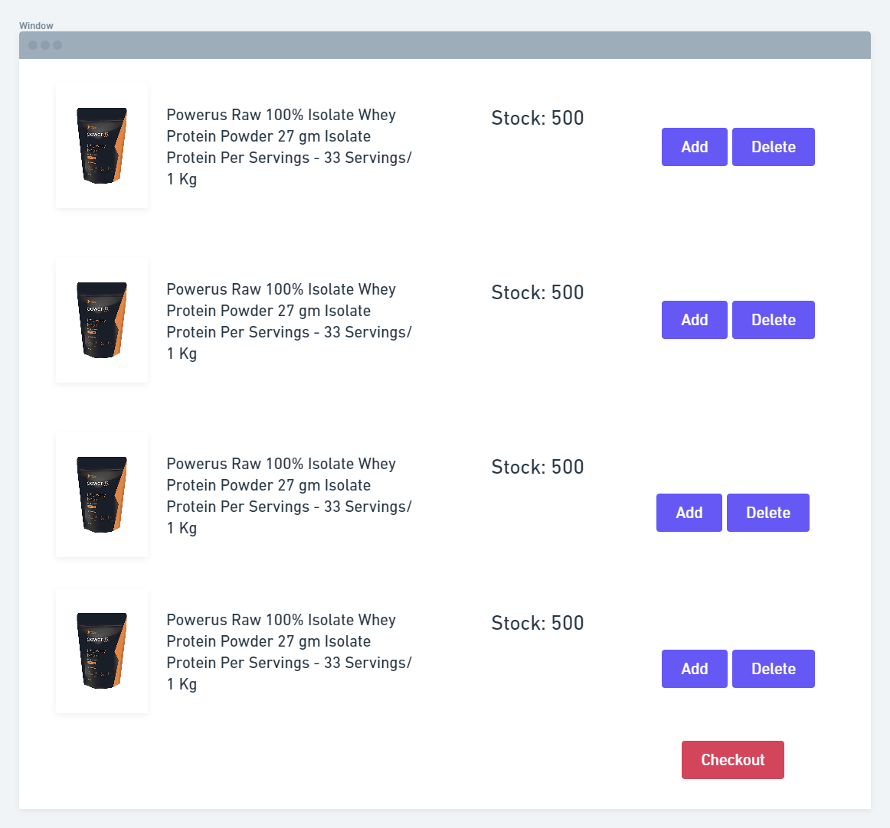

* Pharmacists can also update the inventory from the refills tab. When a pharmacist has any item out of stock and wanted to place an order with the supplier, that particular list would be updated through the Refills tab, where the pharmacist could customize the number of products needed.

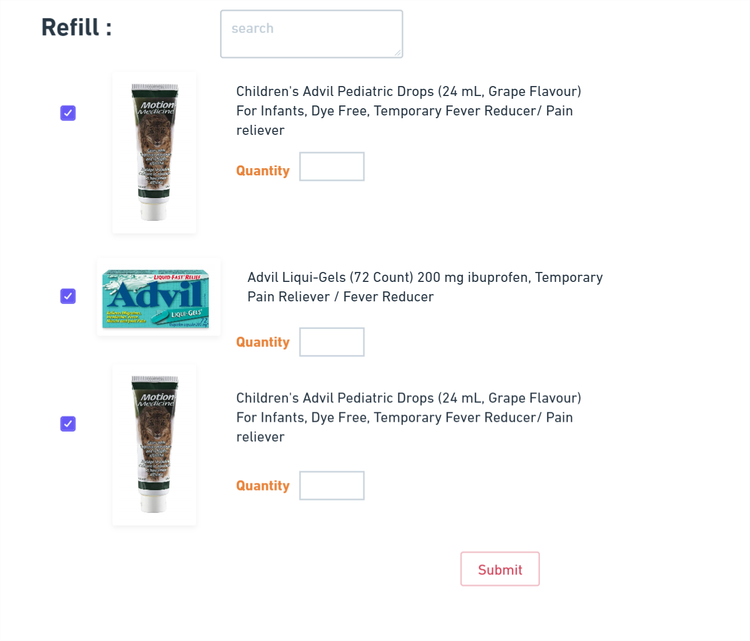

When the logged in user is an Admin

**string sql= select * from admin where username==?&& password==?**

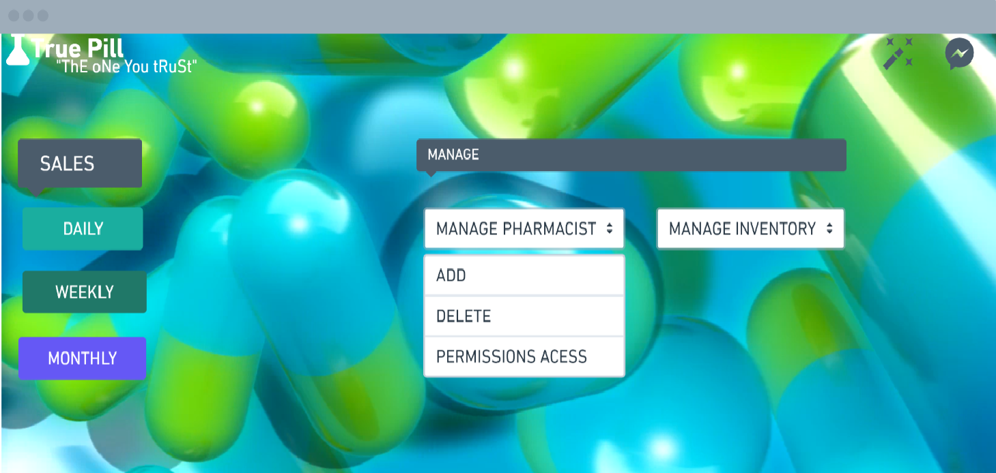

* Admin will have to Approve the Inventory requirements which the Pharmacist has added, Only then the orders would go to the Suppliers and once the orders are being obtained from suppliers, the pharmacist will update the inventory list with the new stock.
* Admin will get the Sales Reports on the Daily, Weekly and Monthly basis.

When the User Logged in is an SuperAdmin(Executive Manager)

**string sql= select * from superadmin where username==?&& password==?**

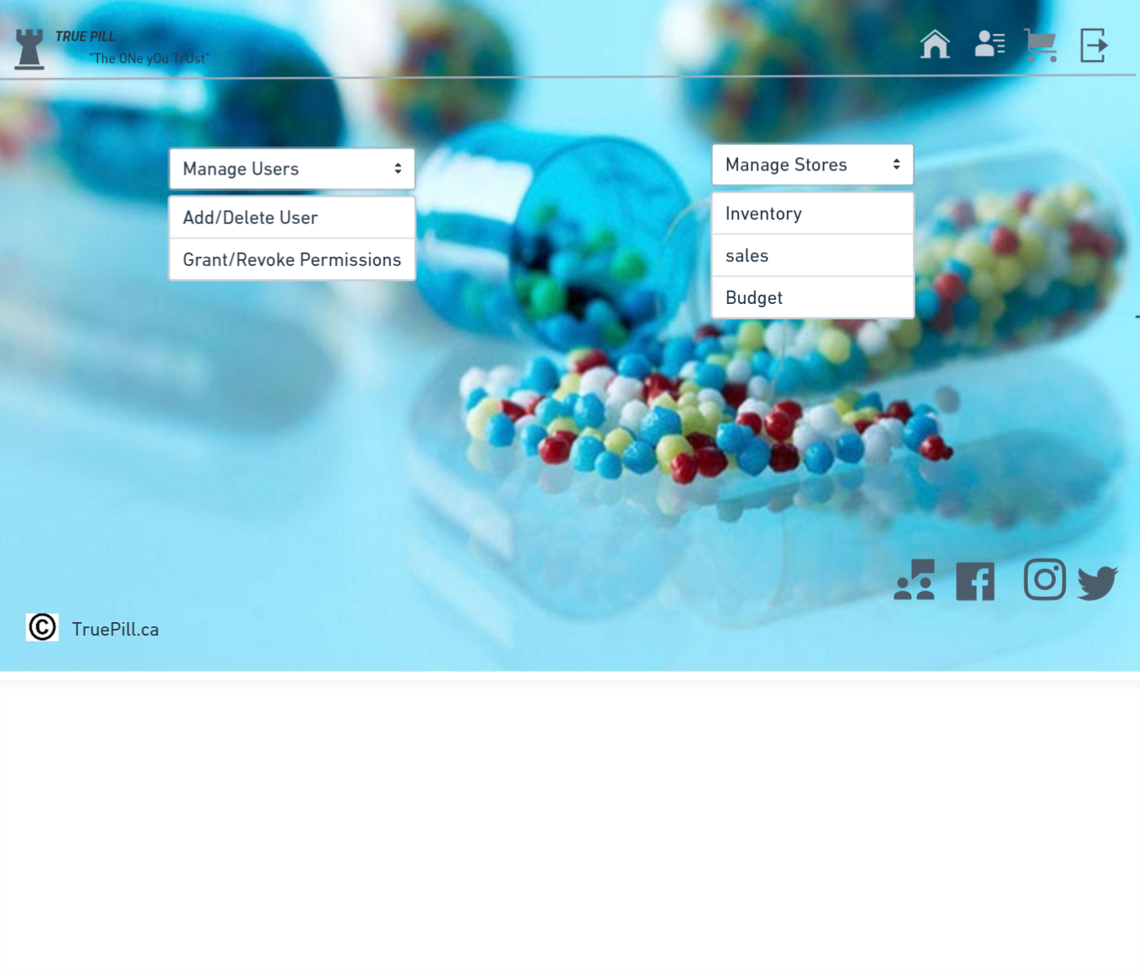**ANDROID**

This page is for the pharmacist, store manager and executive manager so that they can login and perform the necessary activities.

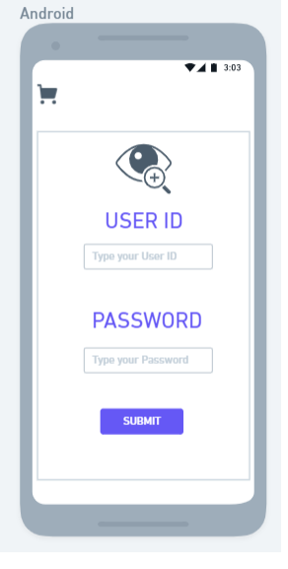

This is used by the store manager and executive manager to check the sales report and to add or remove a pharmacist

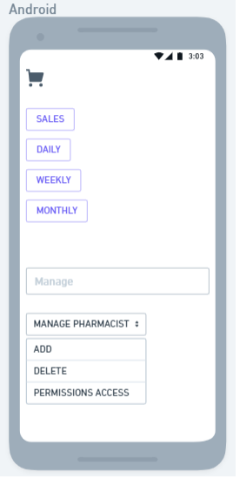

This page displays the list of products that are added to the checkout page.

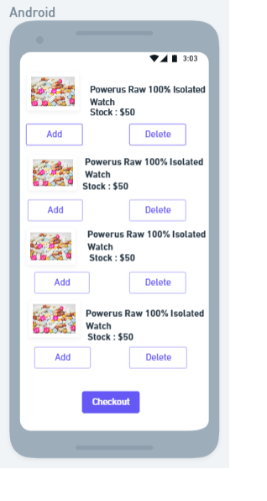

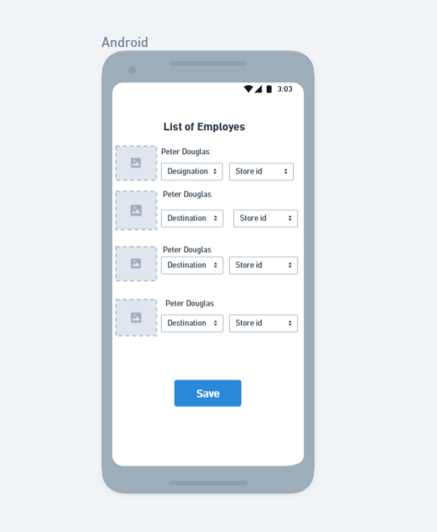

This page is used to display the list of employees/pharmacists who are working in the store which contains their designation and store id.

**The Super Admin/Executive Manager will be able to Add/Delete the Users, Provide Permissions to the users. Also multiple stores can be managed by each category such as the Inventory, Sales, Budget for each store depending on the Id and the store location.**